For Participating In
FIS World Snow Day
Diploma Is Given To

Name of
Recipient

January 22, 2012
Tsakhkadzor
Armenian Ski Federation

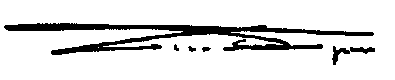
z

Gian Franco Kasper
President International Ski Federation

